**Assignment 1 – File System Management**

1) List out 5 files in your system which consuming most of the disk space

du -h

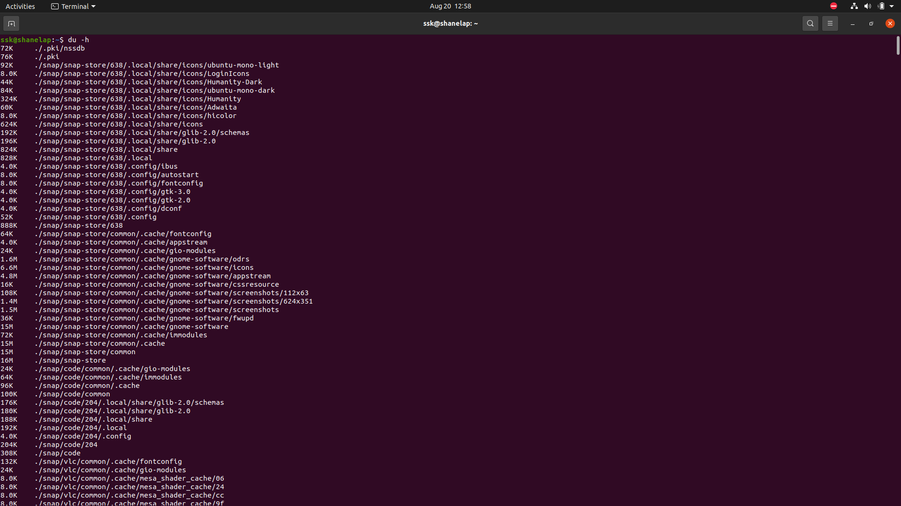

find / -type f -exec du -h {} + 2>/dev/null|sort -h -r|head -n 5

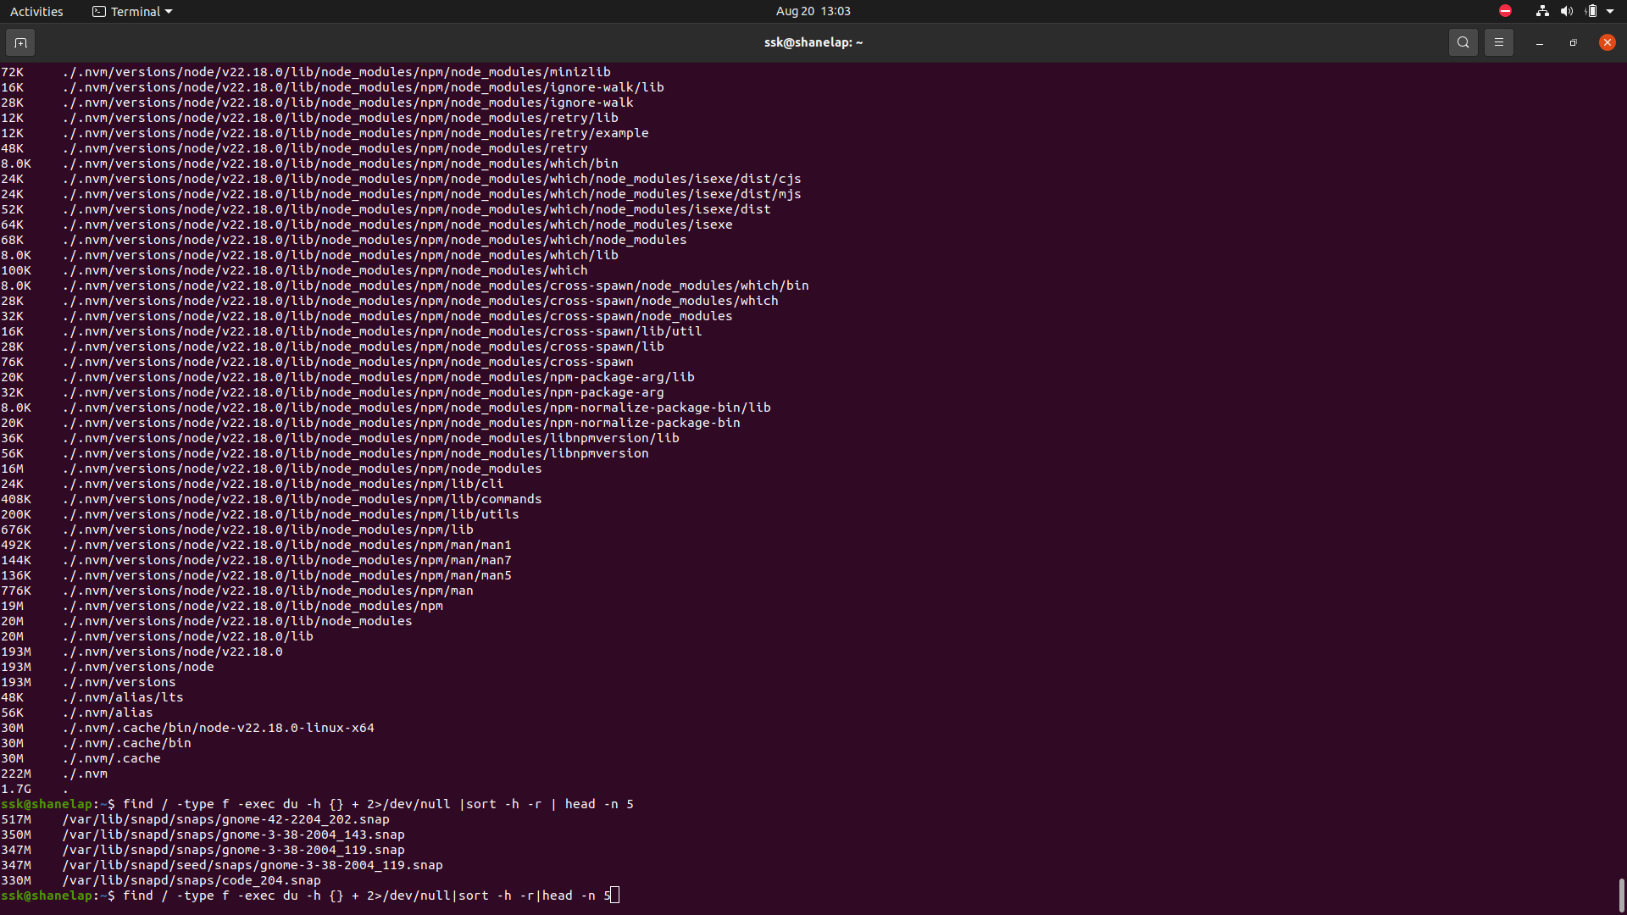

2) Create one common folder in such a way that anyone can create files inside that

independently and should not be able to delete other users files from that common

folder.

mkdir common

chmod 1777 common

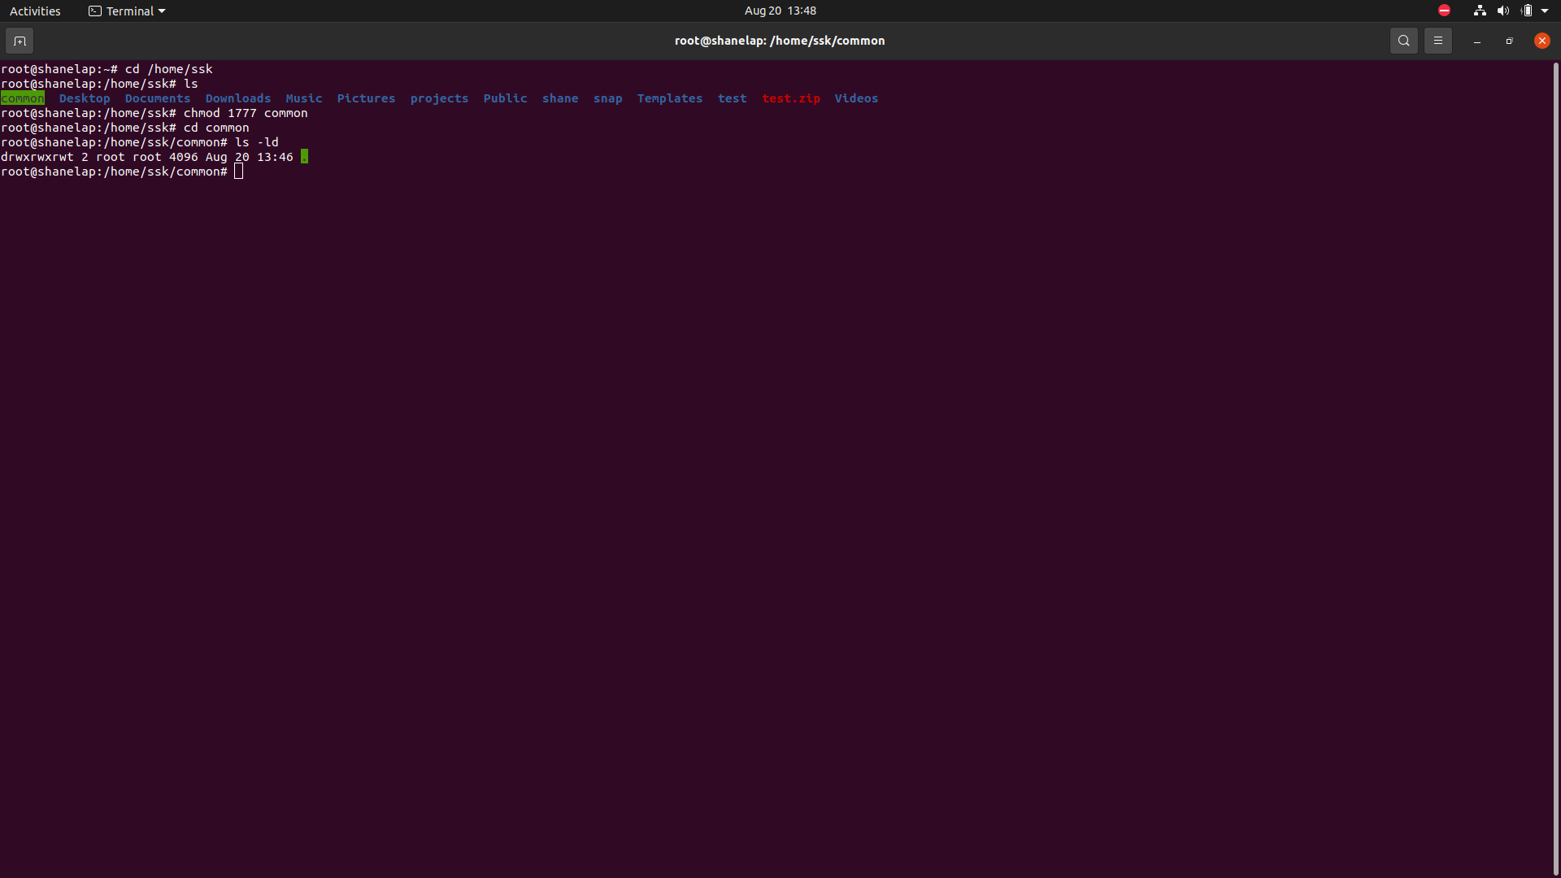

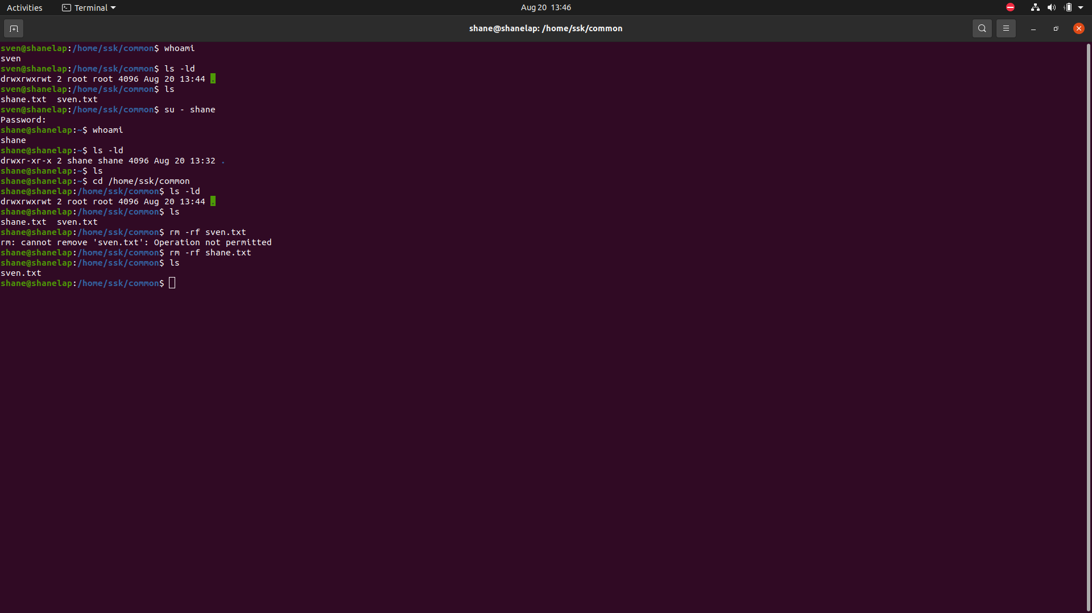

3) Create user name "shubham" and add that user in the group "adm"

a) Create folder /data , change owner and group as "root:adm

b) Change /data permission such a way that user can able to write data in this folder

and ownership of files or folder which you creates in this folder should be same as parent

folder i.e /data folder permission (root:adm)

root>

useradd -m shubham -s */bin/bash*

*passwd shubham*

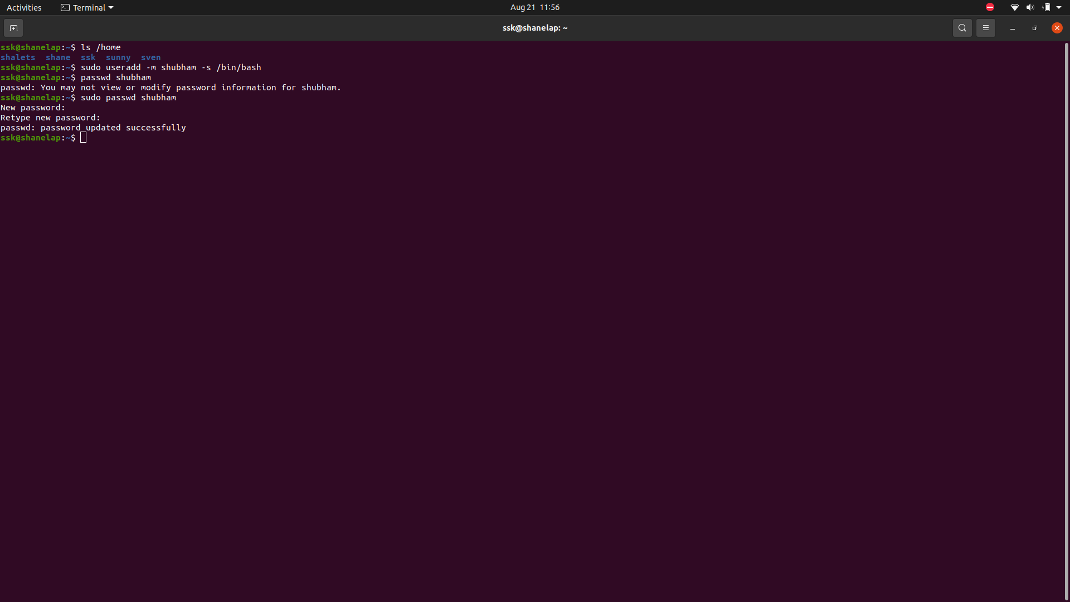

*groupadd adm*

*usermod -aG shubham adm*

*mkdir data*

*chmod g=r+w+x /data*

